Some images of website:

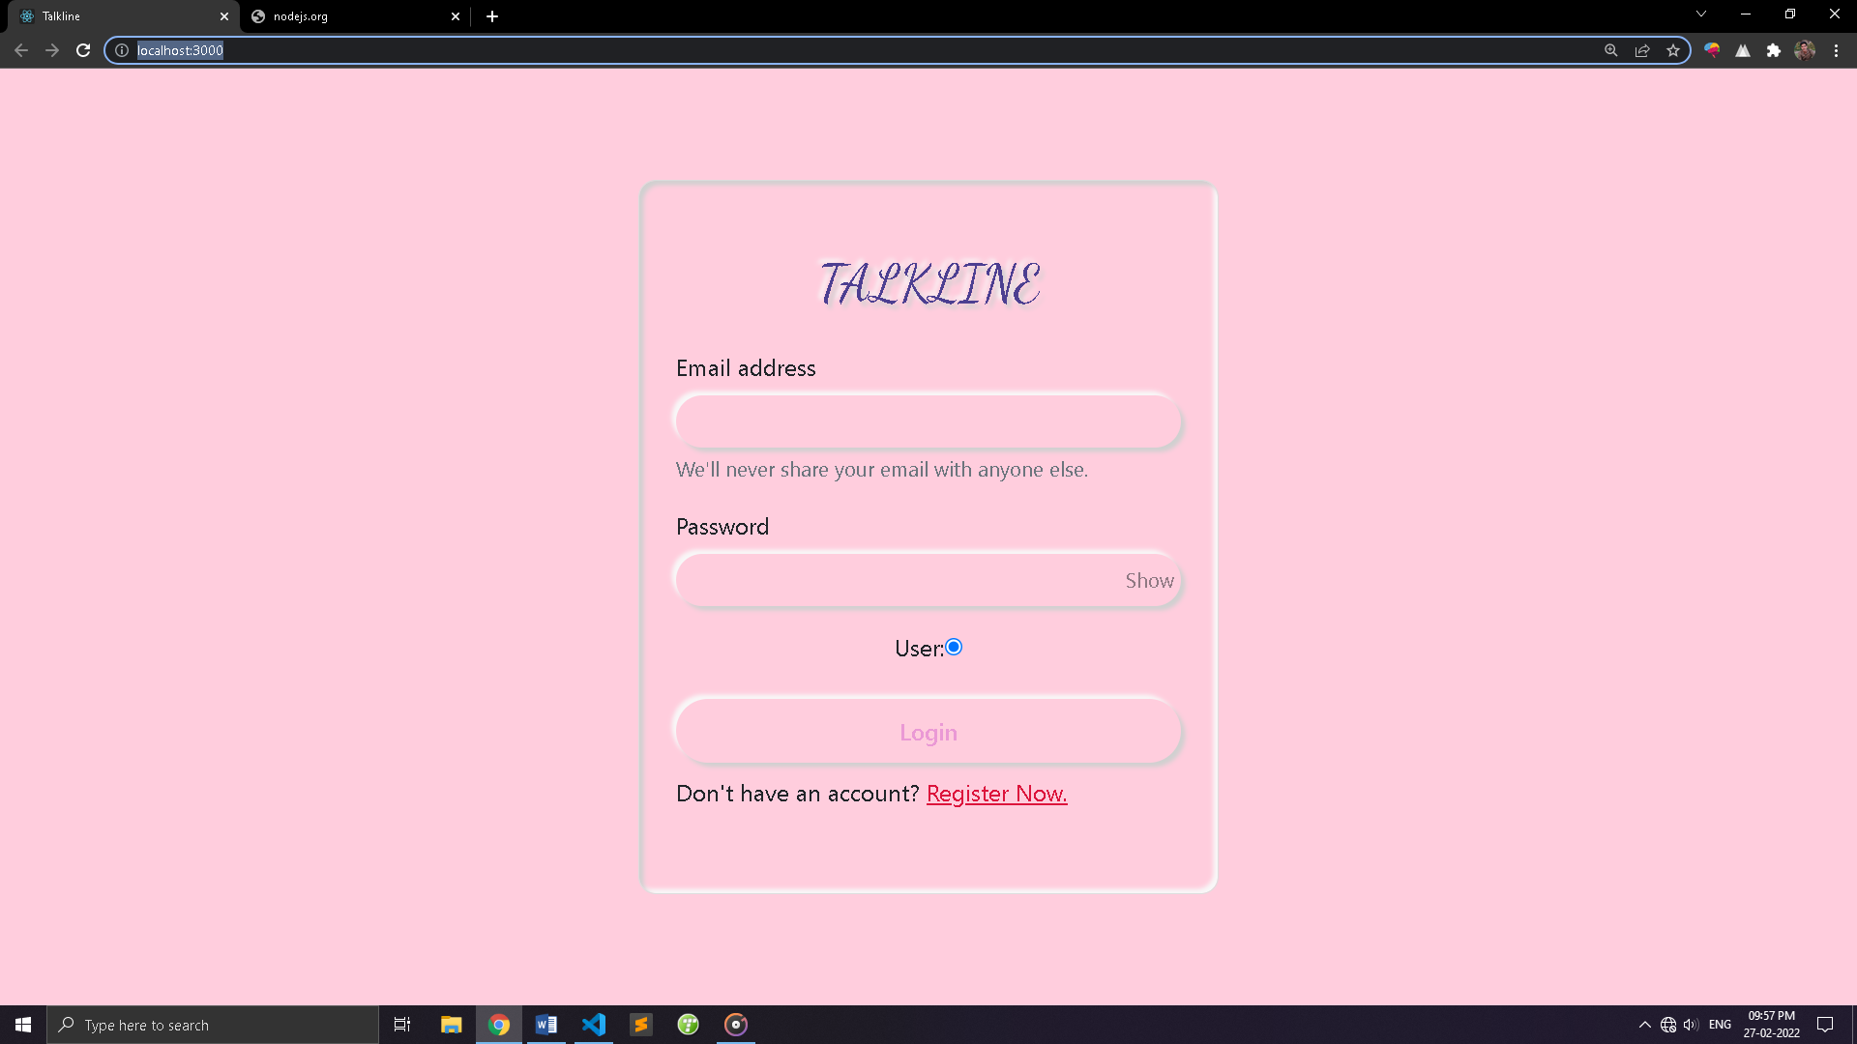

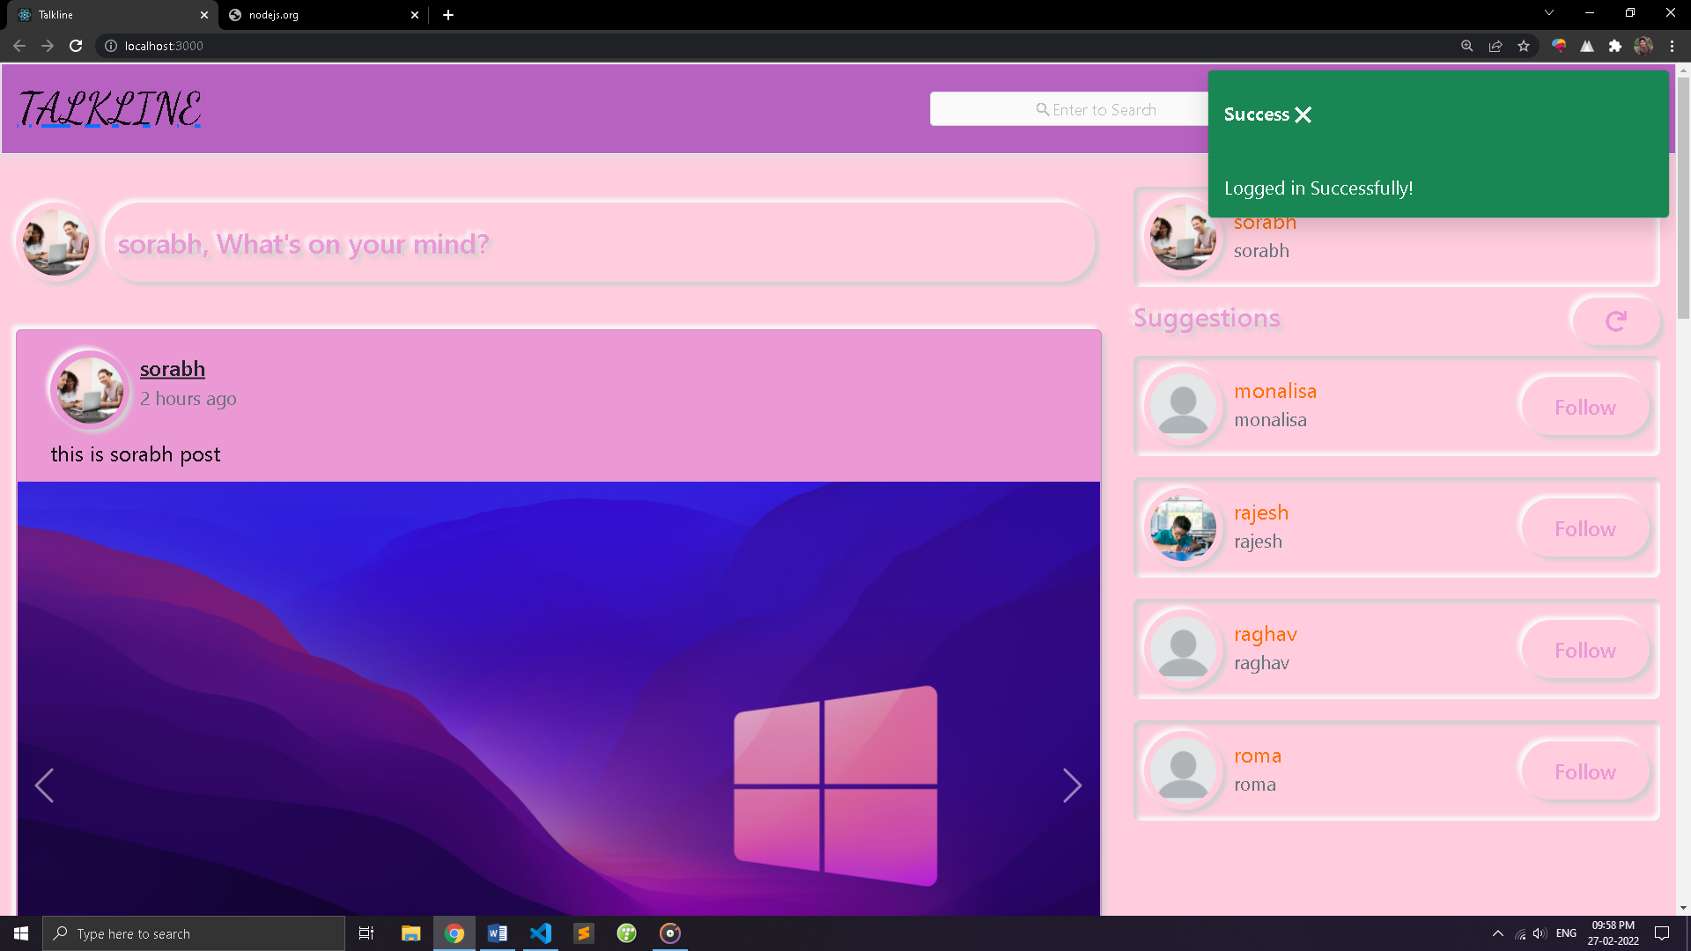

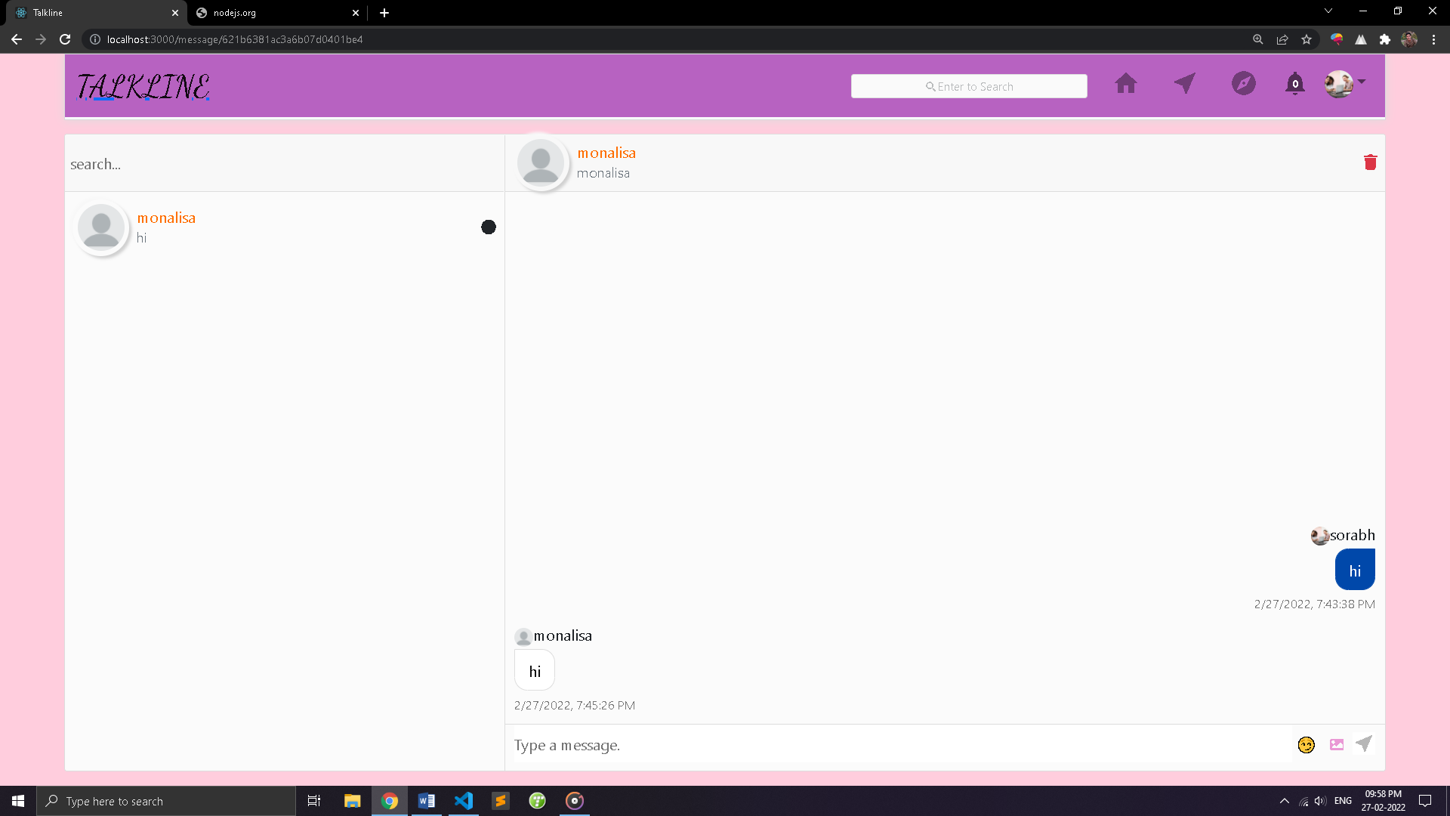

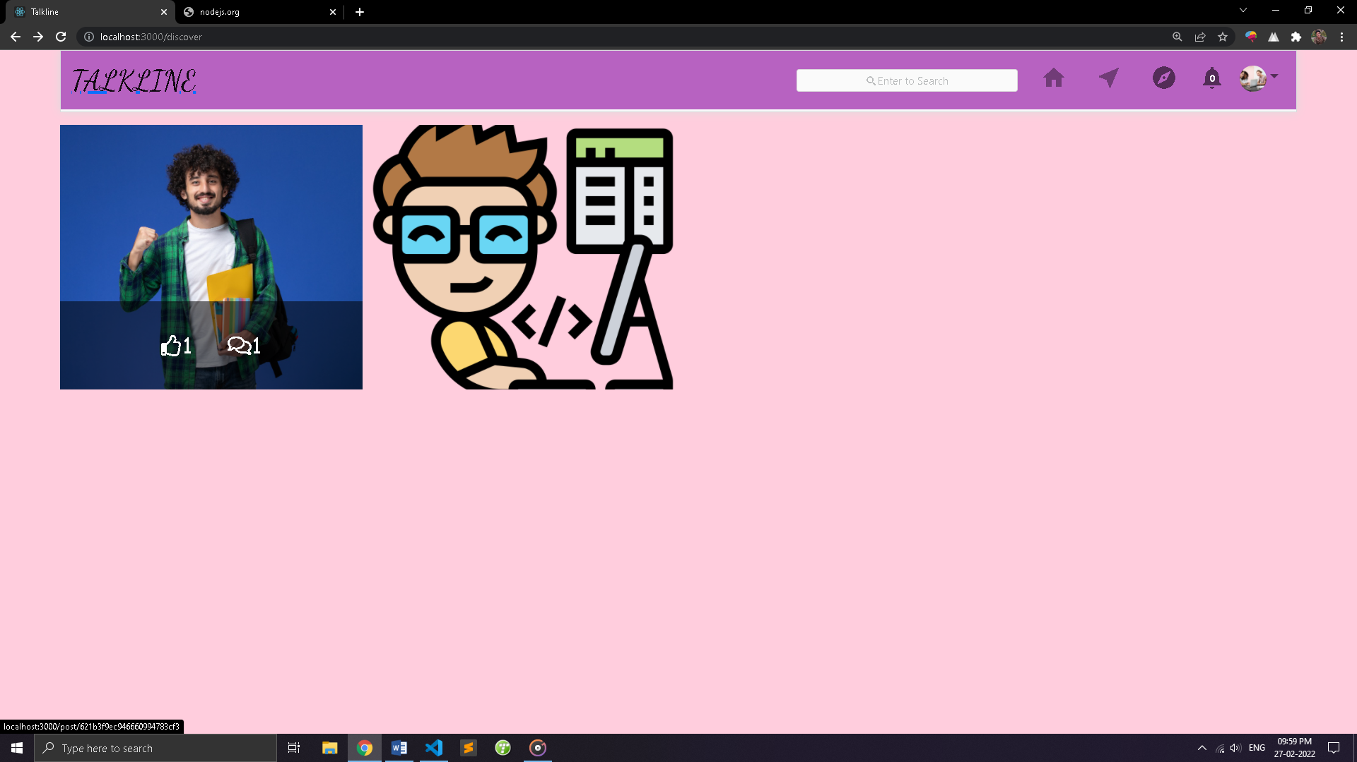

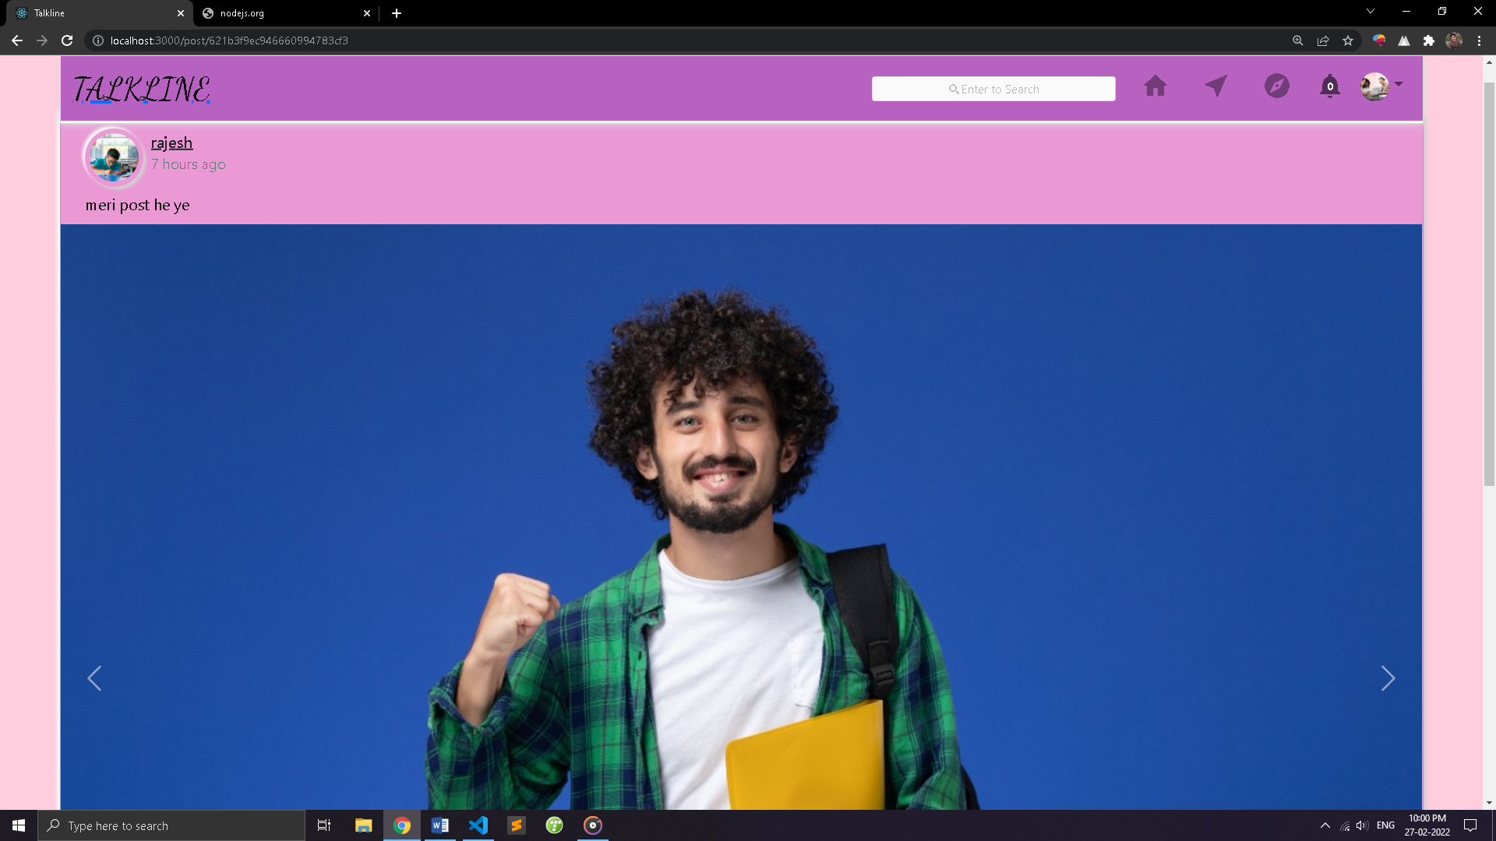

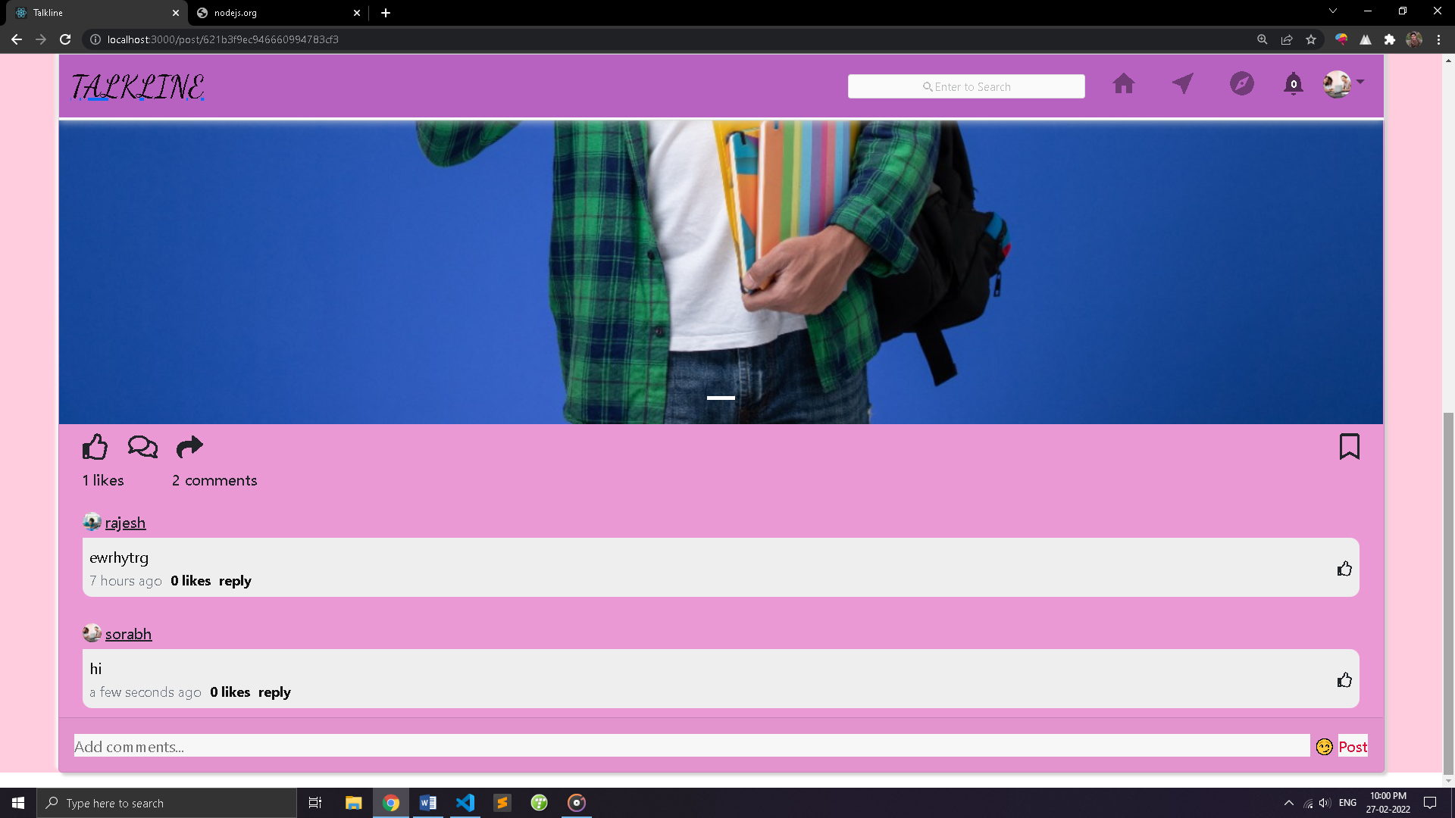

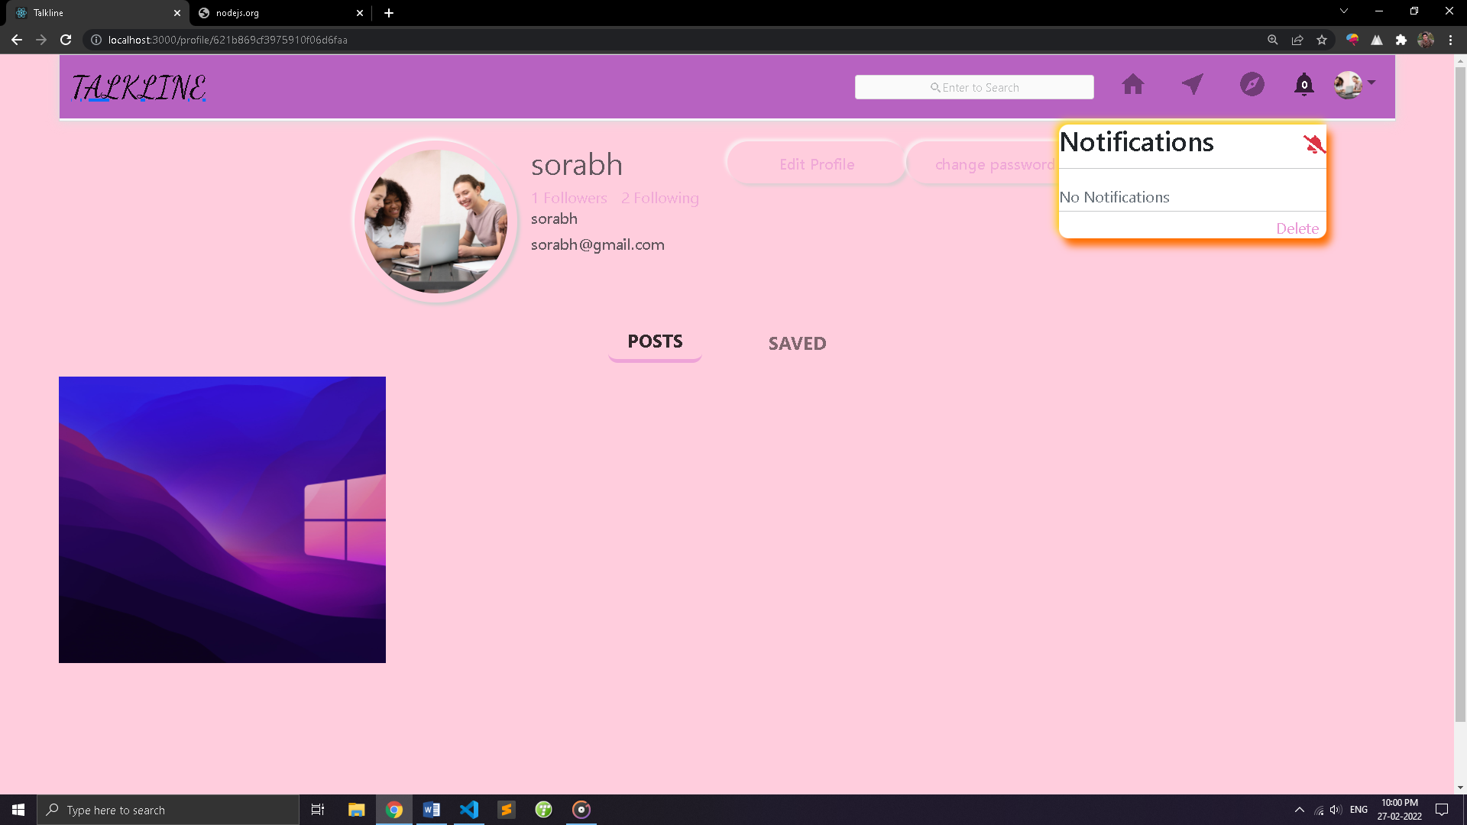

INSTALATION

Install nodejs form there official website <http://nodejs.org/> and follow this steps :

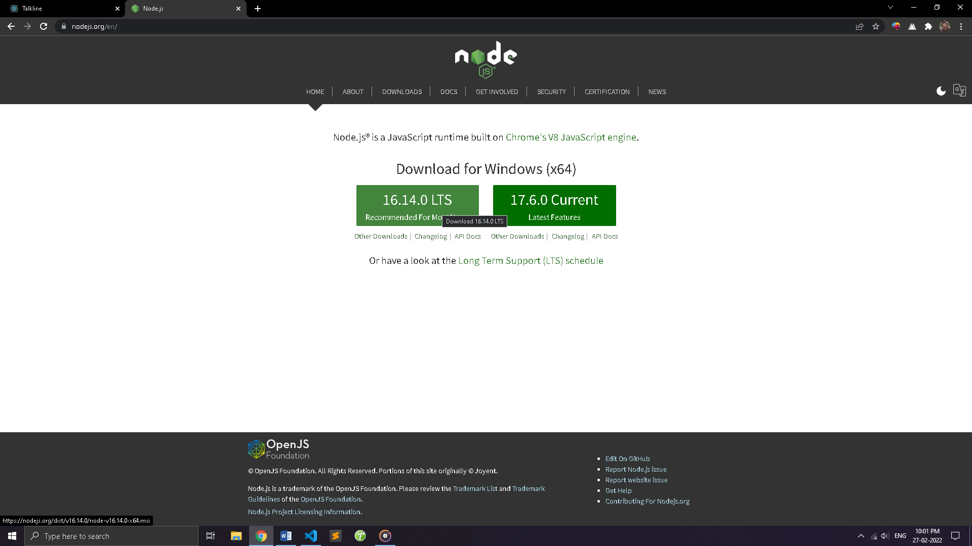

Then click on next and install in node js

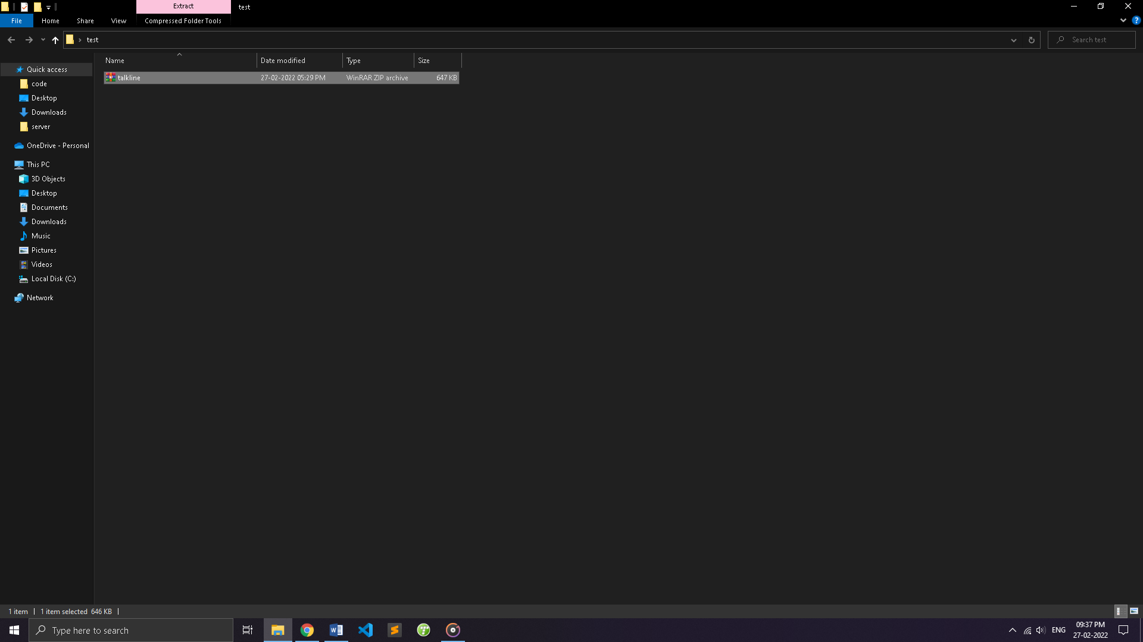

Step:1 Extract talkline zip file.

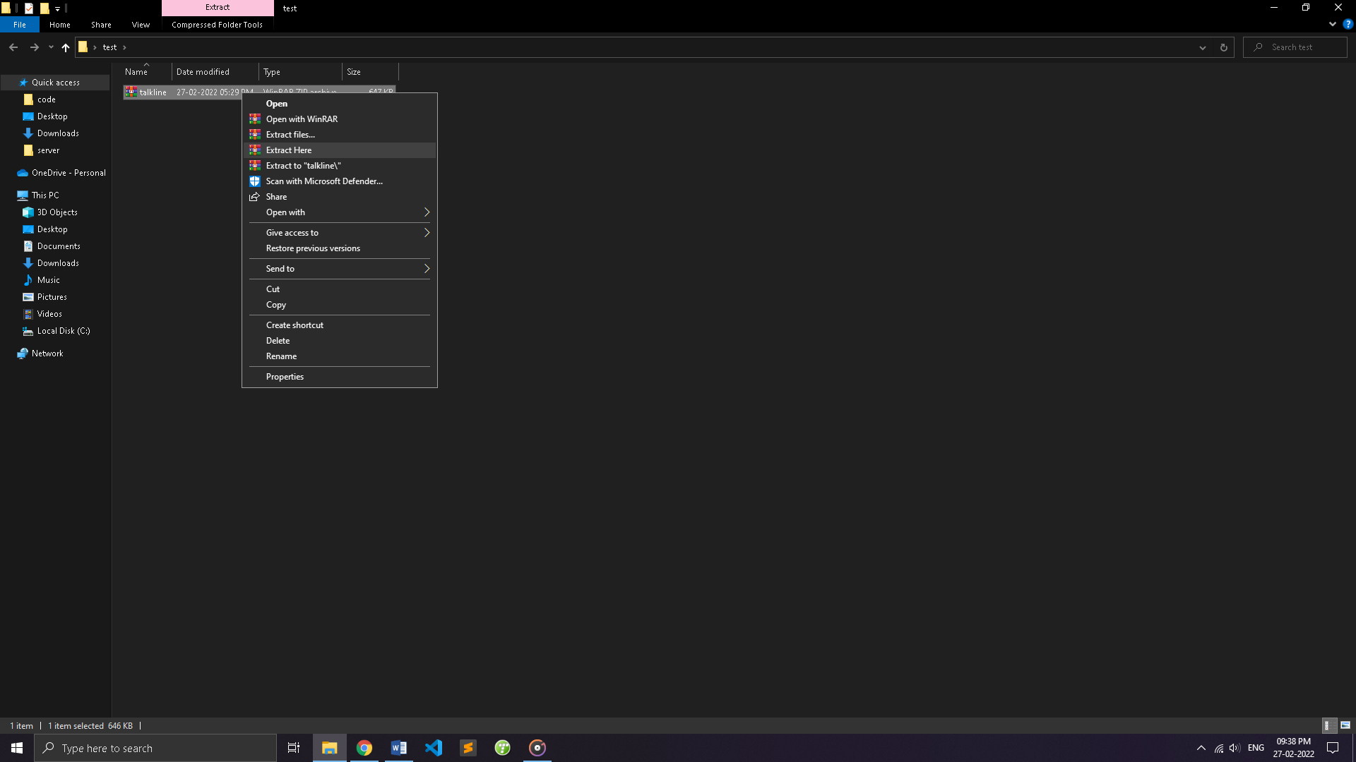

Step:2 Open talkline folder using vscode

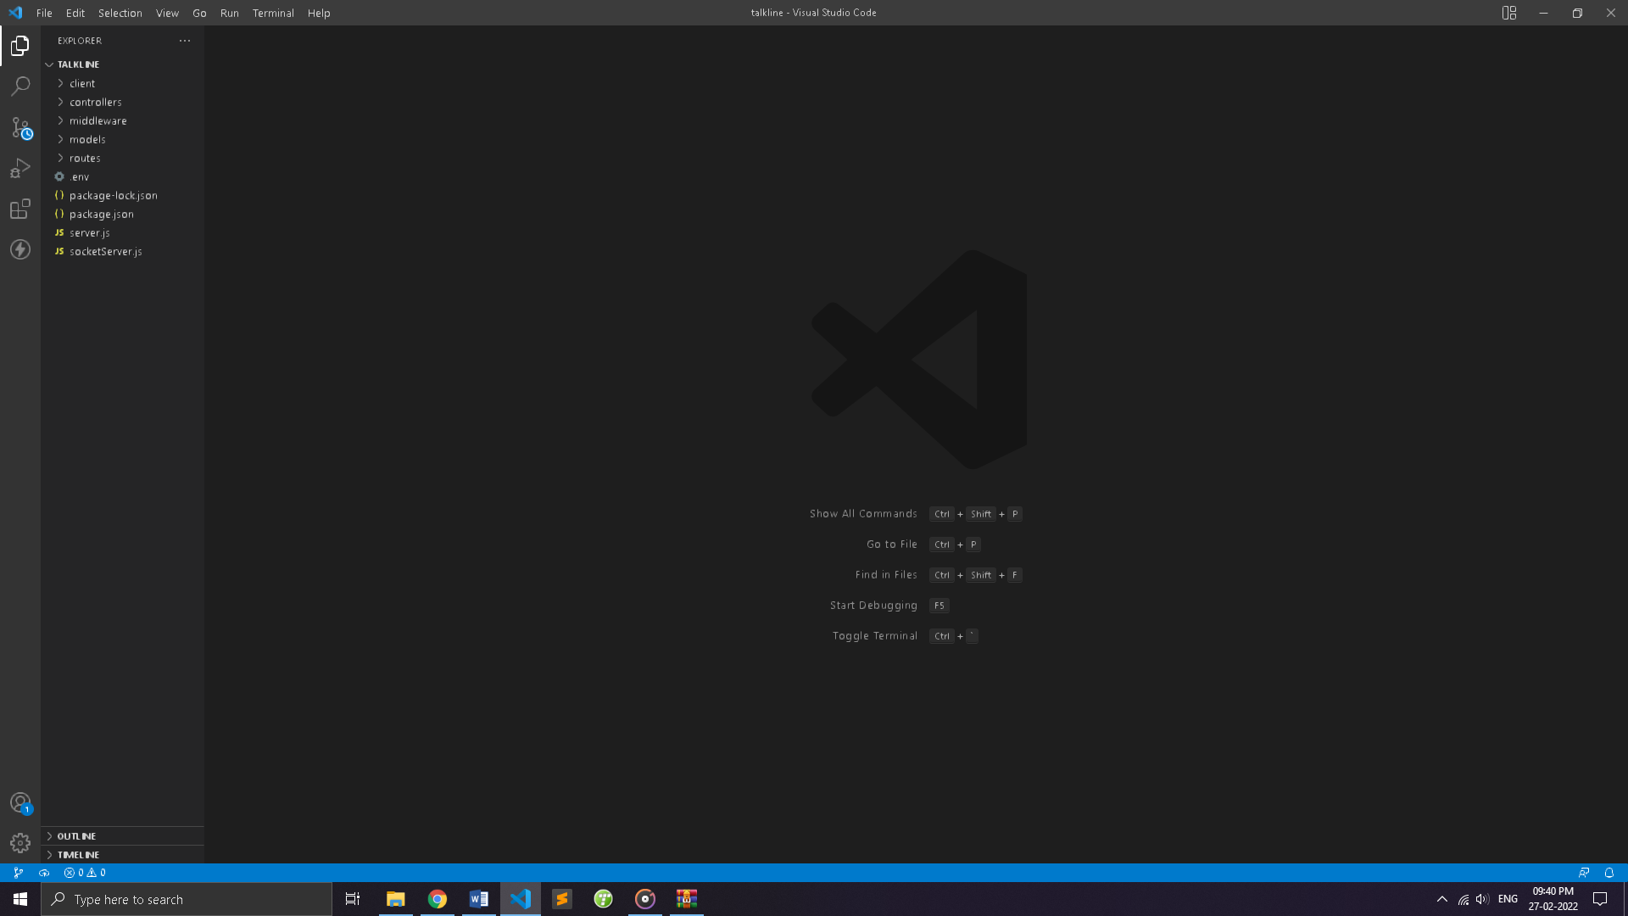

Step:3 Open New Terminal.

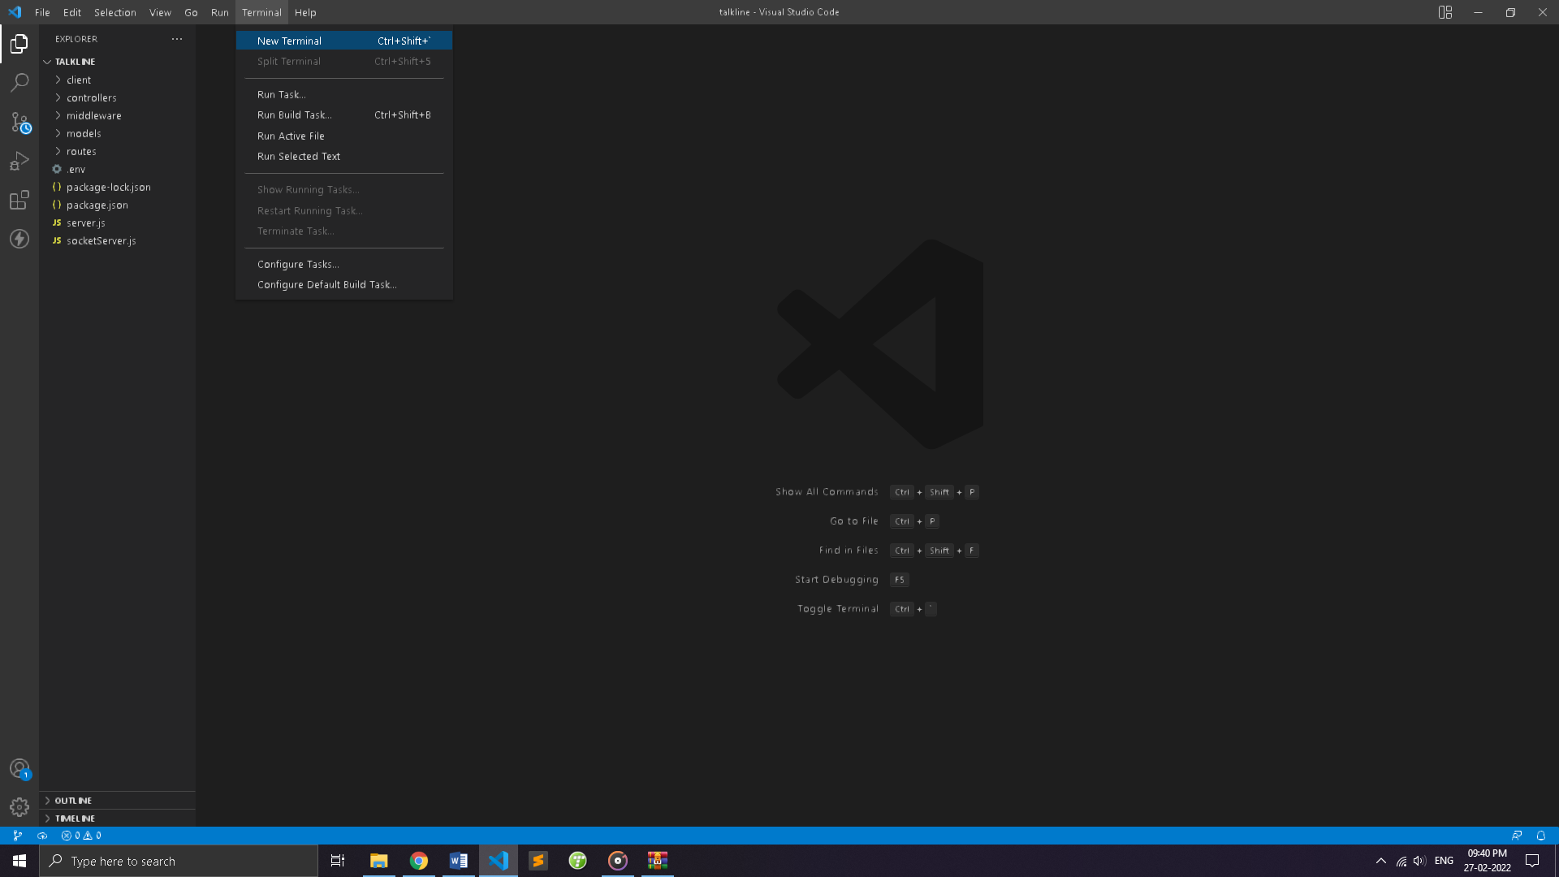

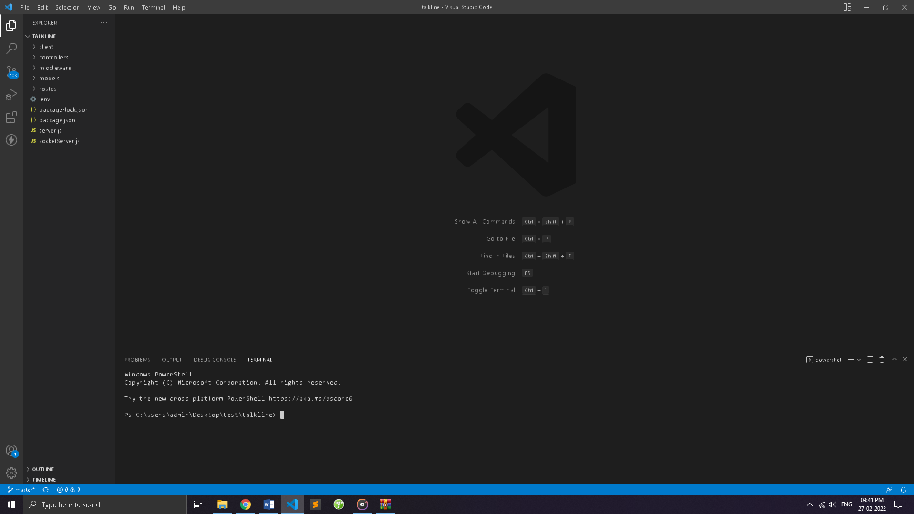

Step:4 Click on Split terminal or (ctrl+shift+5)

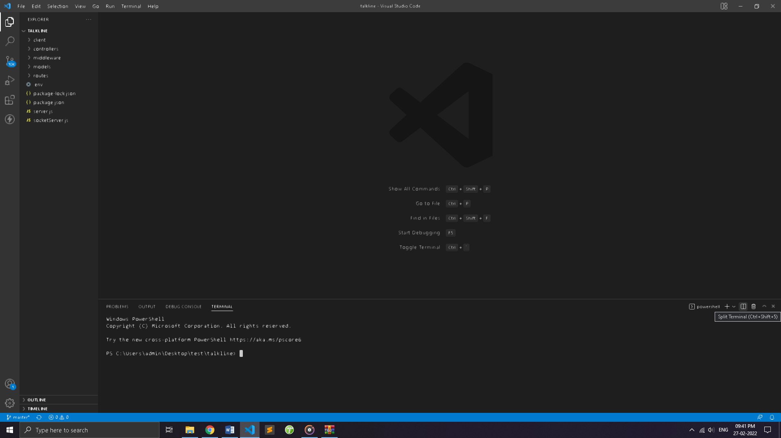

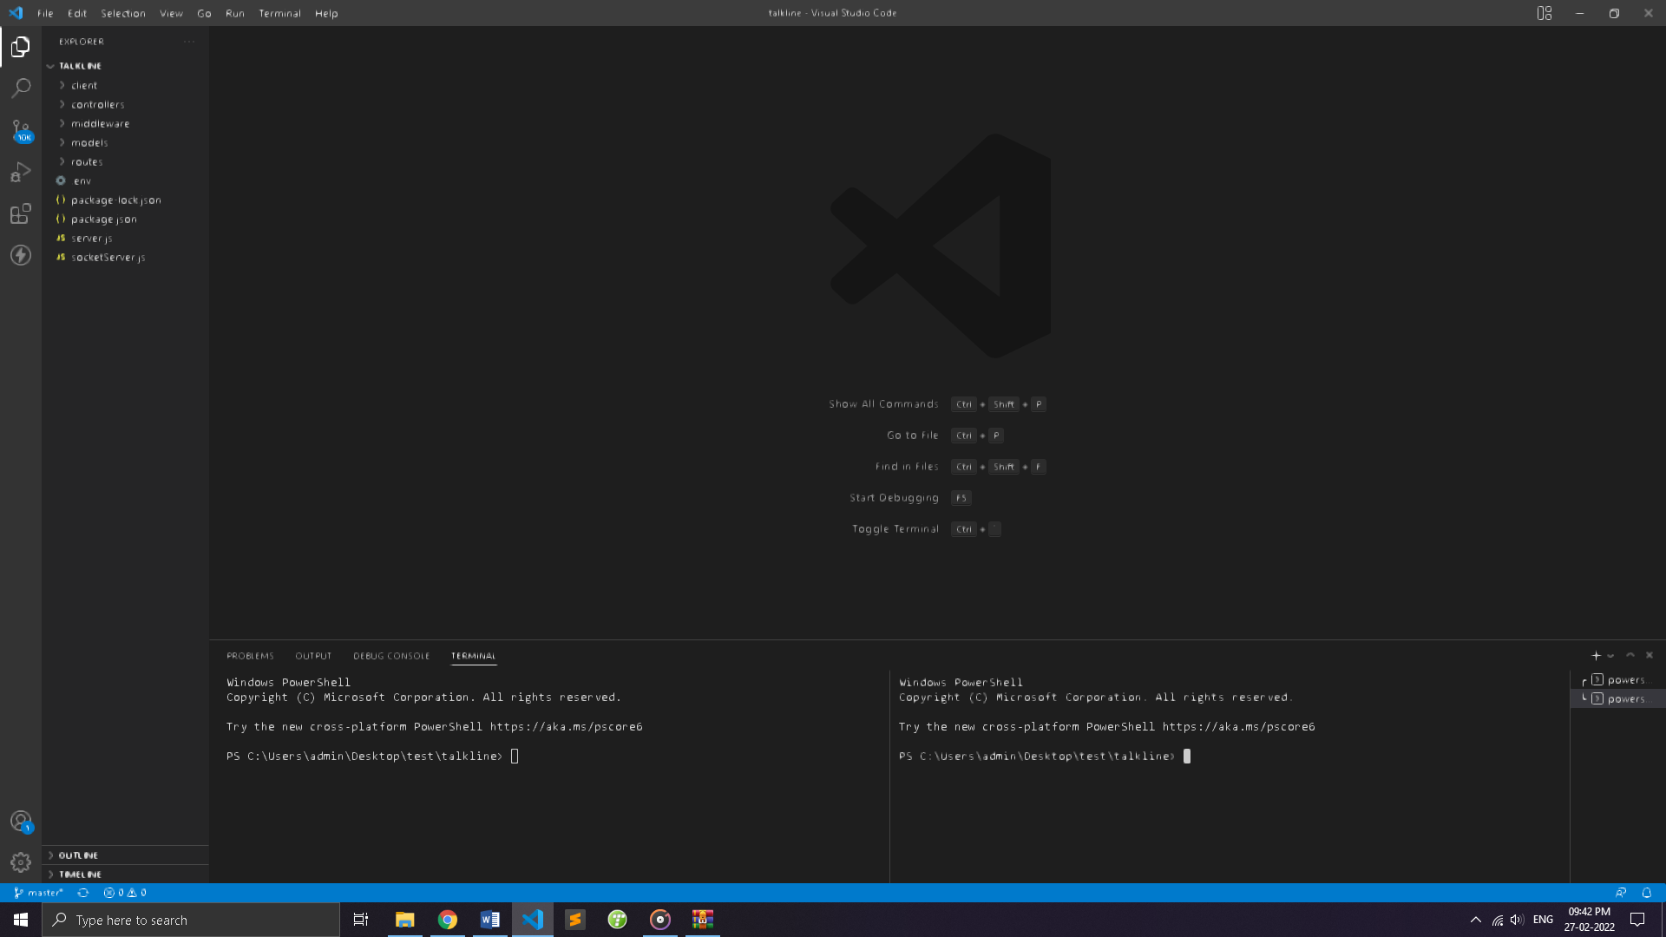

Step:5 write npm install on one terminal and write cd client on 2nd terminal and then on second terminal write npm install. (this process done once to install all required packages)

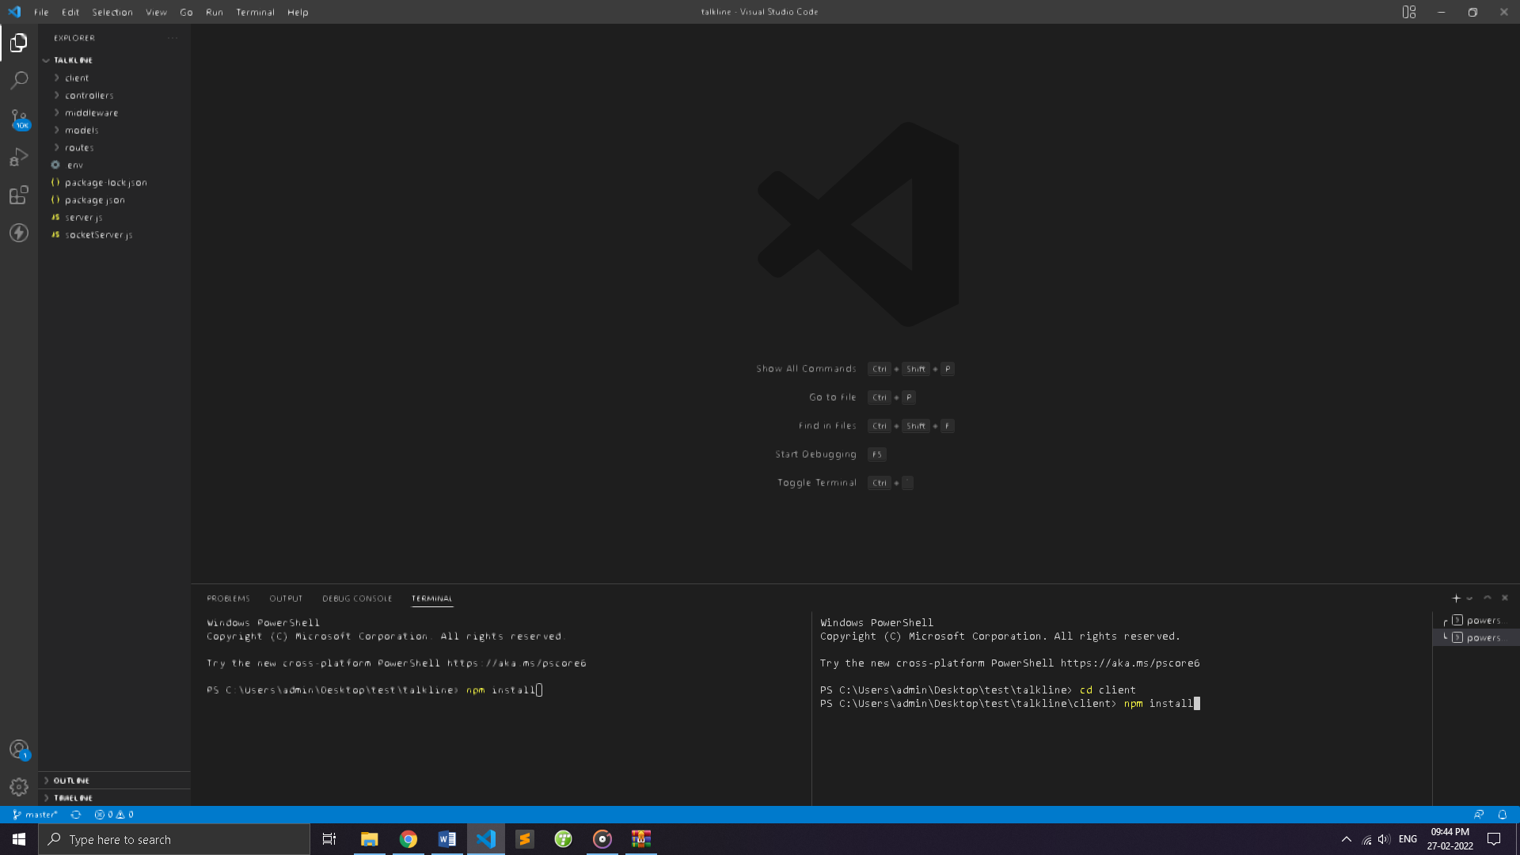

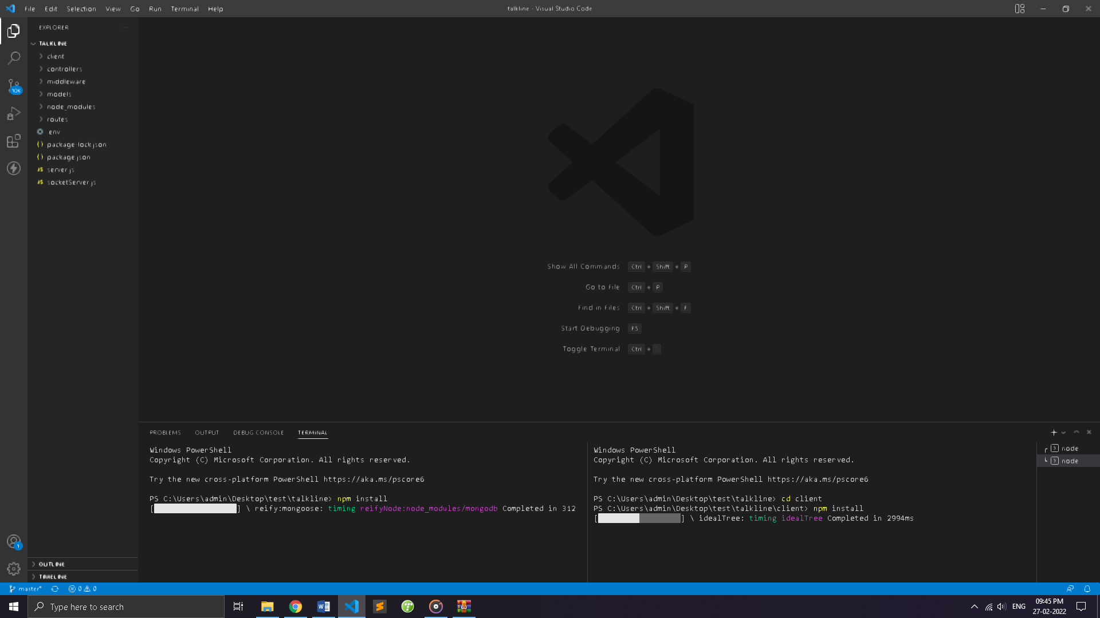

Step:6 terminal without cd client type “node server” (to run backend server)

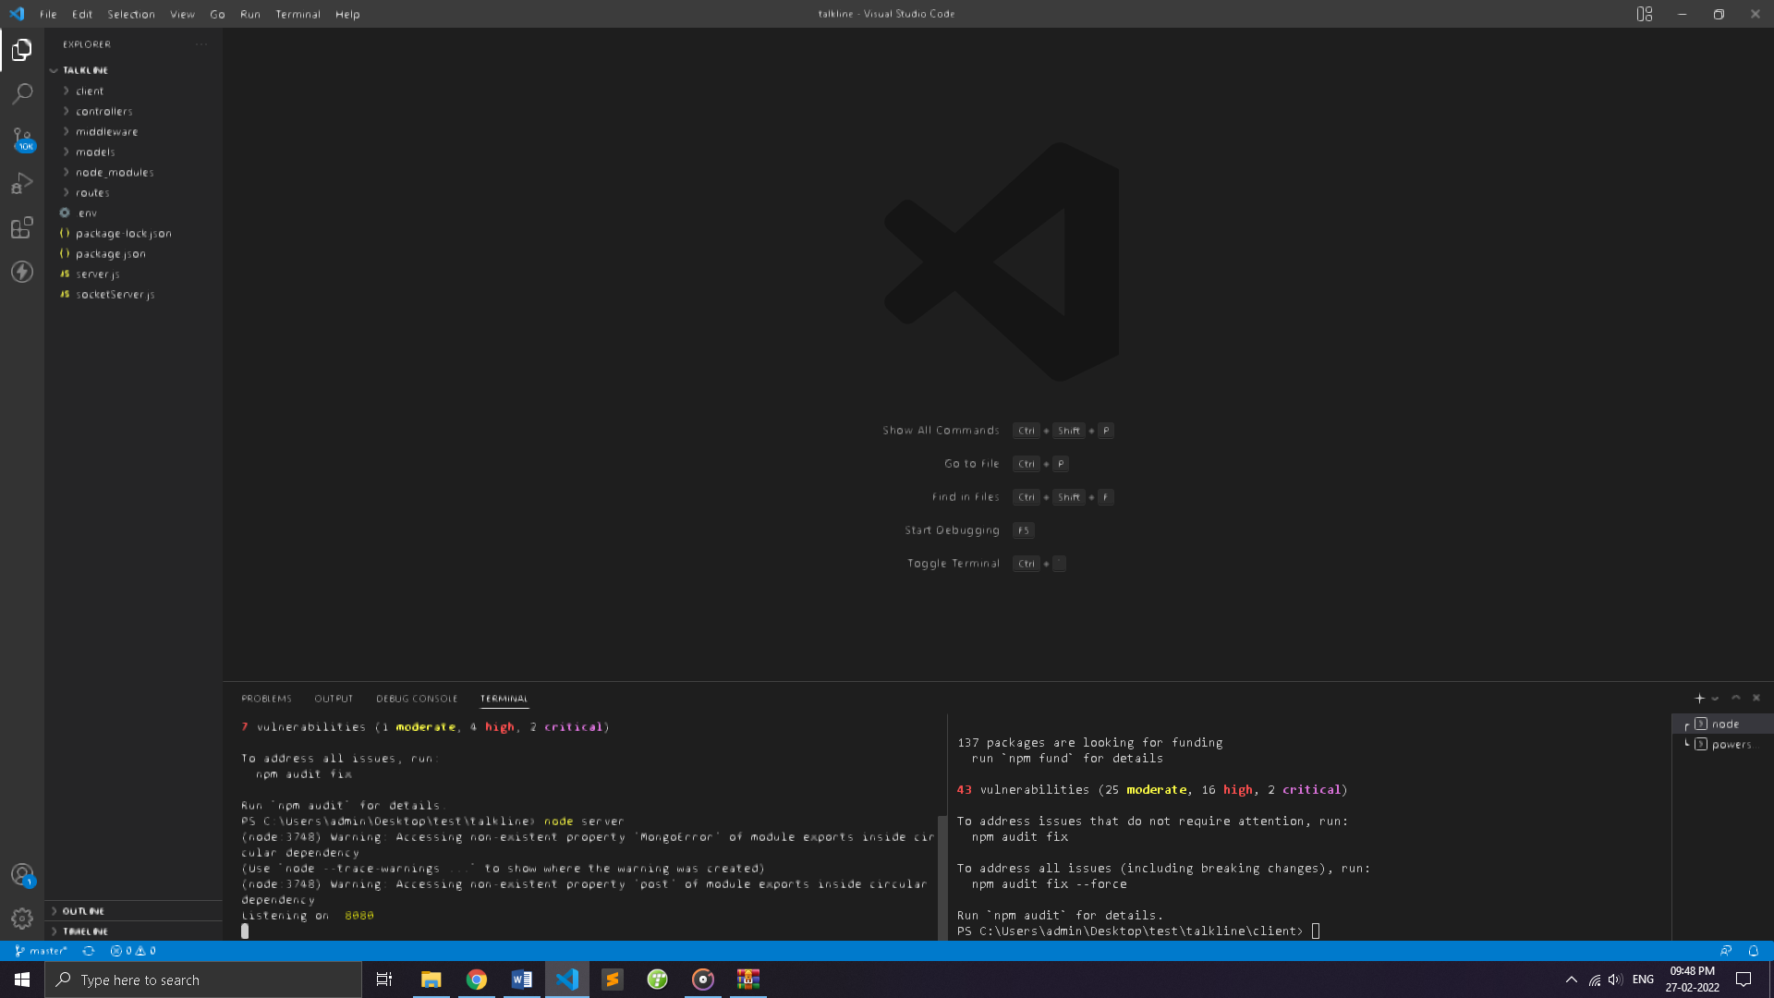

Step:7 terminal with client type “npm install” and press enter (to start react frontend)

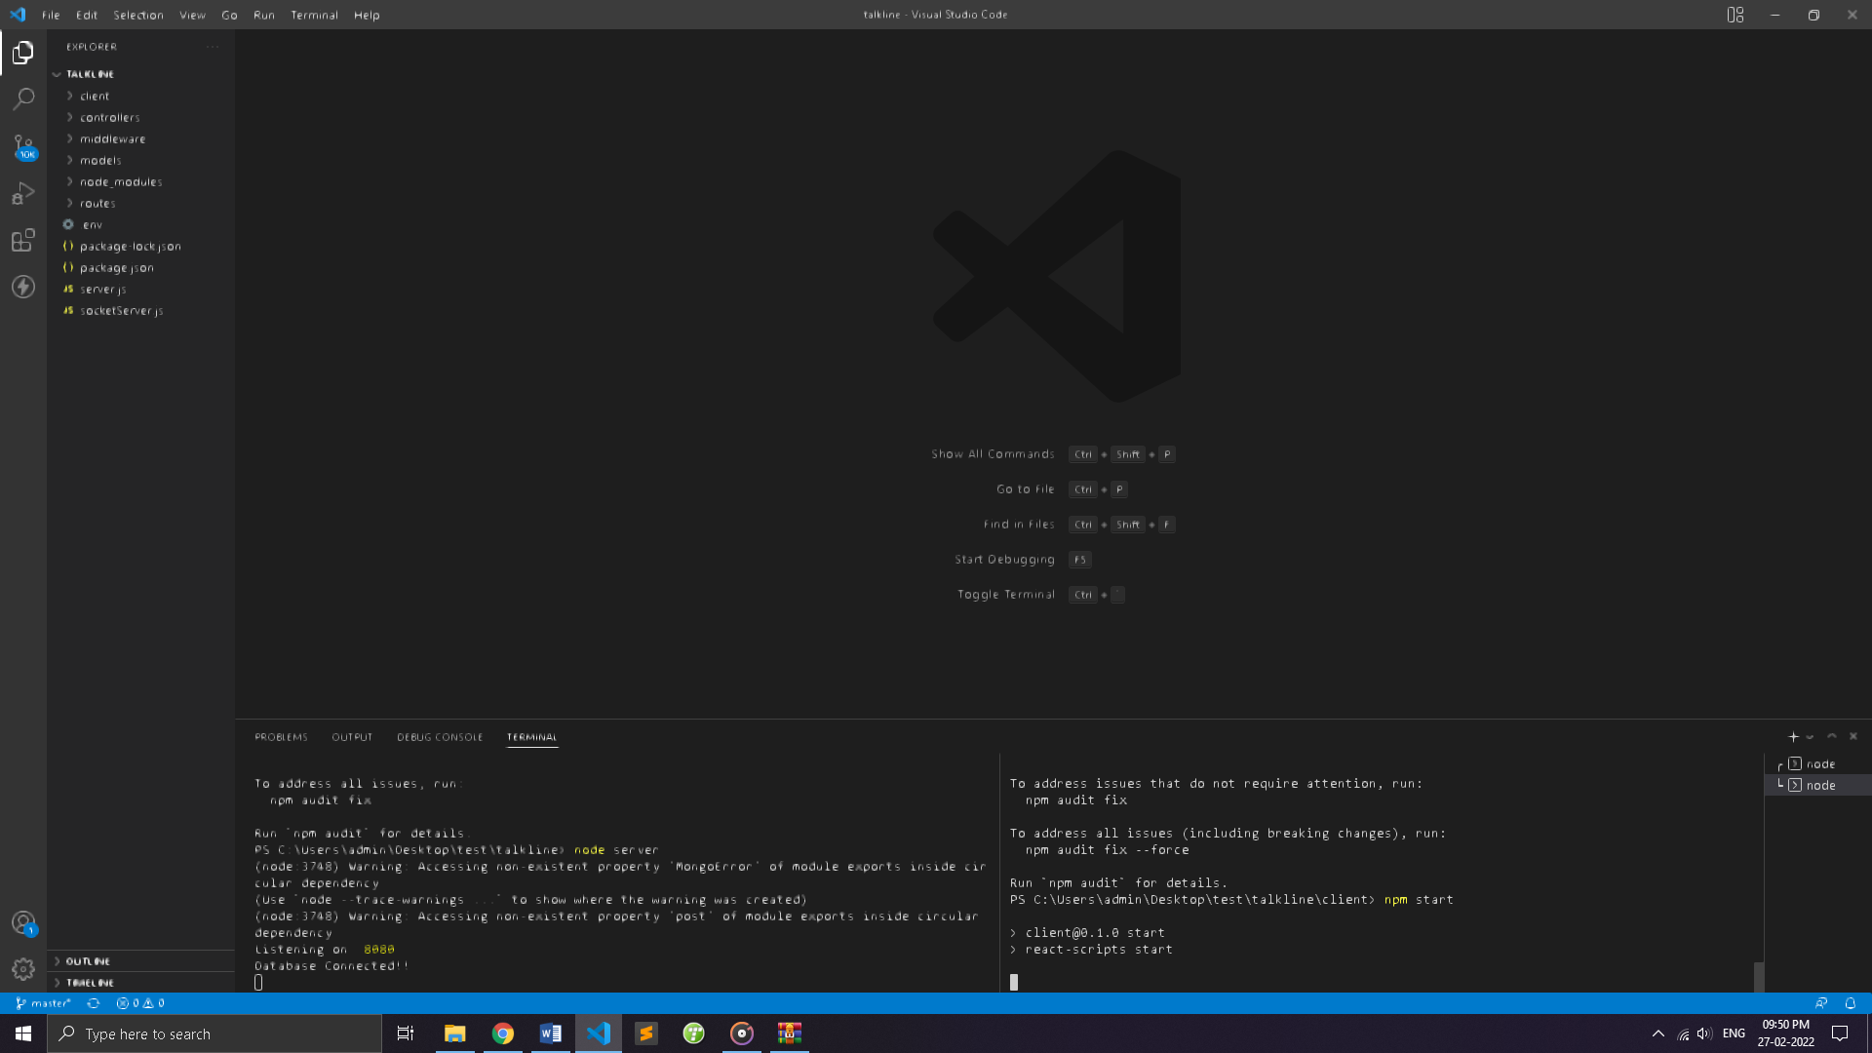

Step:8 wait for 2-3 minutes till which react will load . now your website is live on Url <http://localhost:3000/> and let’s login and enjoy.

Note\* Step:6 Is only for first time.